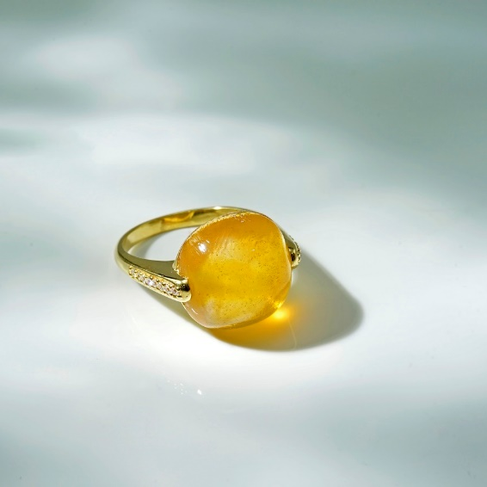**You know, amber stone in general and beeswax amber in particular has been bestowed with an extremely attractive "power" by nature, allowing these stones to have a positive impact on people's health. use. Scientists have discovered that on this stone there is a layer of Succinic acid, which is the type of acid that folk often call amber acid or amber acid. This acid plays an extremely effective role in the treatment of diseases related to bones and joints such as arthritis. People also often choose to wear this type of amber for children because Succinic acid also has anti-inflammatory properties, enhances resistance, helps children always be healthy and happy in life.**

**Net Weight: About 4g**

**Ring face: Approx 16X17MM**